**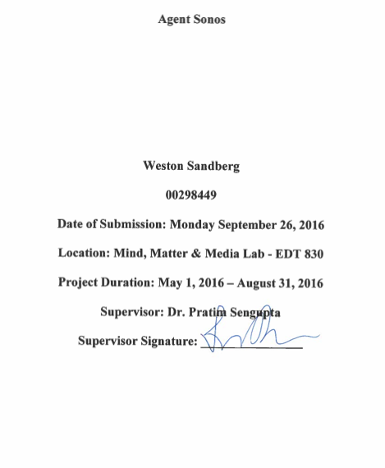**

**Introduction**

My research involved two components a) the design and development of new technologies for musical composition and b) a study of the creative practice of live musical performance using these technologies. This research has raised many new questions, such as the relationships and differences between learning in *public* and learning in *private*, as well as, designing pedagogical approaches for learning in and as public through the creation of live, collaborative, and computational music. Because of these questions, my research is ongoing and perhaps the trues insights will not reveal themselves for years to come. My summer began with the simple question “What have I learnt?” But has since become the question “What could others learn from a similar experience?” My goal in this report is to further illuminate these issues.

**Project Description & Outcomes**

1. Design and develop new technologies for musical composition
   1. **Agent Sonos**

Agent Sonos is an intuitive simulation for musical composition that explicitly engages users in creating visual, audio, and mathematical patterns, using which they create music. Built upon a Cartesian grid, the notes play from left to right. This program also includes user-friendly access to all of the code for easy manipulation of the program itself. This open-source access allows users to edit the program as they see fit. For example, I have designed multiple versions of Agent Sonos that focus on various K12 curricular elements and/or performance qualities. Agent Sonos was built using the NetLogo multi-agent programming and modeling environment.

**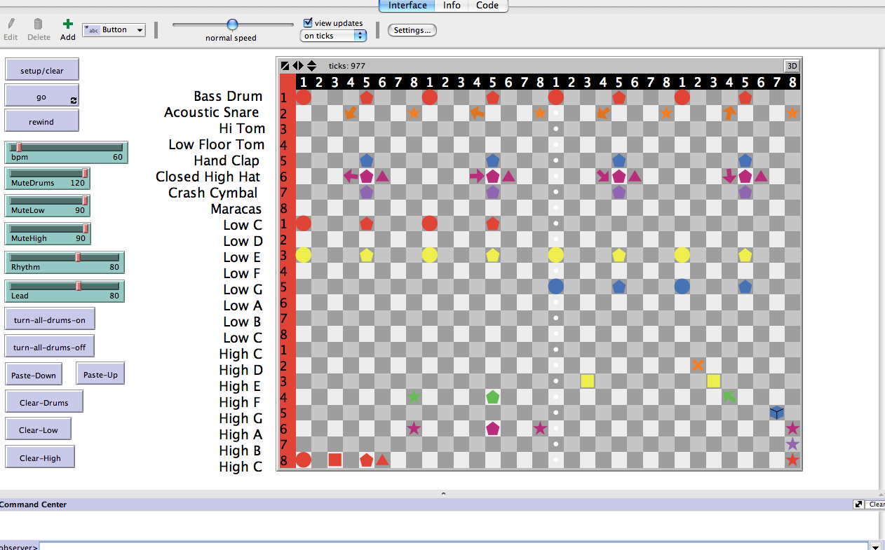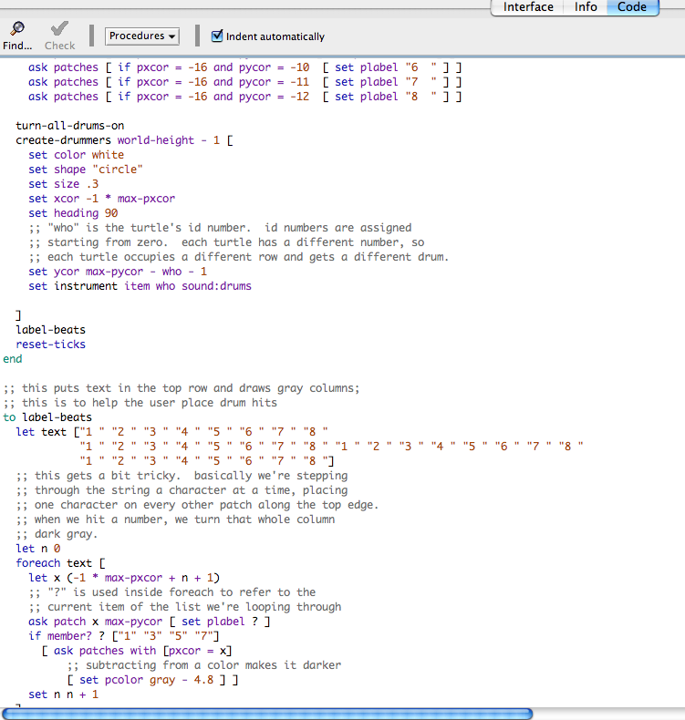**

* 1. **Hacked Guitar**

We developed a paradigmatic “hacked” guitar, which comprised of a simple capacitive touch interface mounted on a guitar. These sensors were connected to a computer and a mixing board via an Arduino microcontroller, and were programmed to play pre-recorded sounds to create a live musical composition. When touched, each sensor, in turn, transmits a specific numerical value to a computer via the microcontroller, which in turn trigger various sounds when the appropriate numerical value (representing touch) is transmitted. The programming involved using both Agent Sonos and Processing.

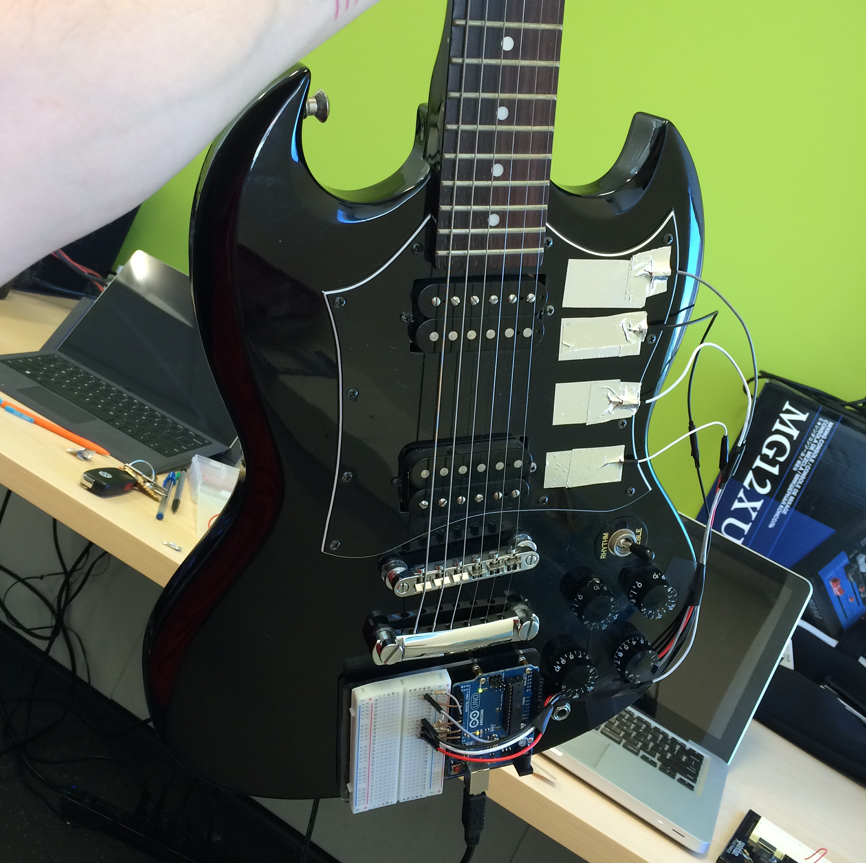

1. Studies of creative practice of live musical performance using these technologies.
   1. **Interactive Outreach**

Agent Sonos was prototyped, demonstrated, and interacted with, during multiple public and private sessions, in educational and informal settings, by teachers, parents, students, and professional musicians, which directly lead me to modify and create various versions. For example, feedback from early education teachers inspired me to design a prototype based specifically around K-2 math curriculum.

* 1. **Jam sessions**

To gain an understanding of the real-life challenges and opportunities for using Agent Sonos for live music composition, I workshopped Agent Sonos during several live jam sessions with professional musicians. This process inspired changes that took a very rudimentary version of Agent Sonos and transformed it into a reliable and user-friendly instrument that has been used for live performances.

* 1. **Live Compositional Performance**

A primary goal of this project, from the beginning, was to put on a live performance using traditional instruments, as well as novel computational musical instruments. On Friday August 5, 2016, with the help of the M3lab, I put on a live jam session in the EDT, using Agent Sonos, a hacked guitar, and traditional instruments. We live broadcasted this session as part of our public outreach to engage in public learning and dialogue. We also integrated various simulations that interacted with the music via microphones and touch screens. The entire performance can be viewed from the link below. [https://drive.google.com/file/d/0B119gADX-DSdRHp3Nk9qX19lUW8/view?usp=sharing](https://drive.google.com/file/d/0B119gADX-DSdRHp3Nk9qX19lUW8/view?usp=sharing" \t "_blank)

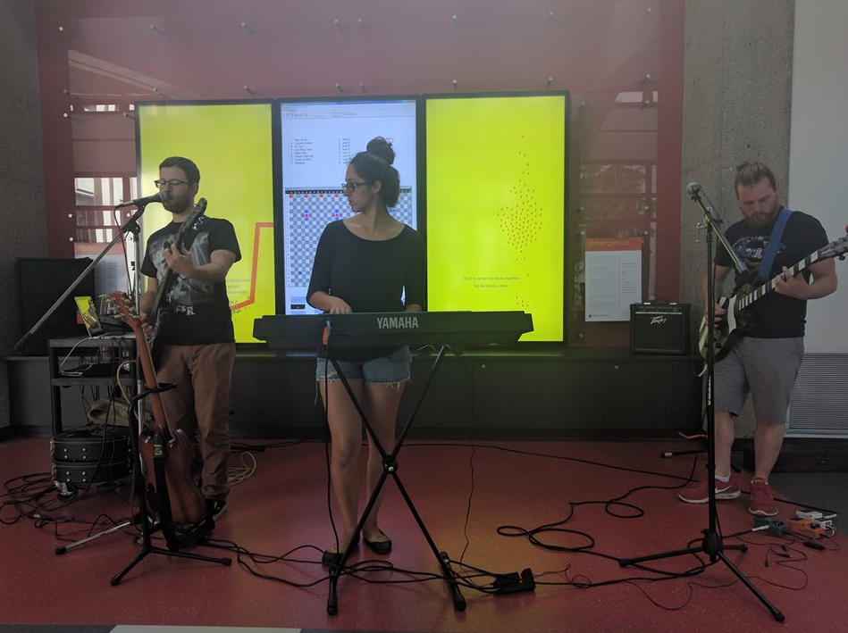**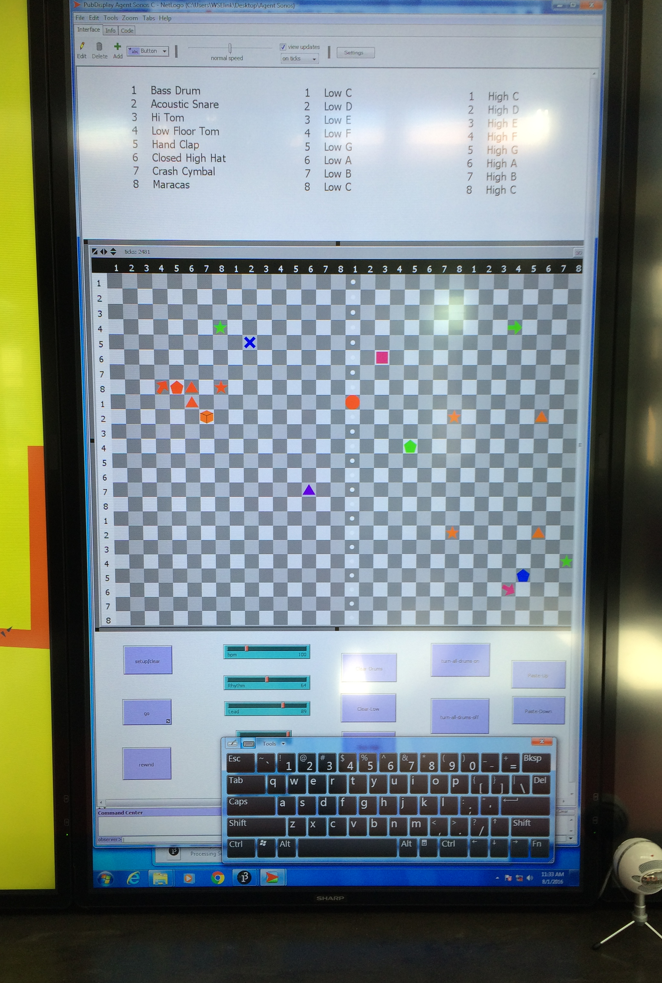**

**Significance**

I have already developed Agent Sonos into a musical compositional tool that addresses K-2 math, music, and literacy curricula. I think there are two strong lines of significance in this particular classroom context. The first being the opportunity to demystify coding so that all teachers have the knowledge and pedagogy to bring coding into the class through their own passions or students passions. Dewey (1929) describes the importance of an interest-based pedagogy in the statement “Education, therefore, must begin with a psychological insight into the child’s capacities, interests, and habits” (para. 7). The second significance being the awareness that coding itself is inherently a curriculum-rich endeavor.

Furthermore this research, specifically the concept of open-source coding and learning has thrown light on the contrast between public and private learning. Often our educational approach is largely focused on what YOU know and not what WE know. The democratization of technology, via the Internet, has really highlighted the strength and opportunity of a collaborative public approach. Furthermore if we work collectively, collaboratively, and emergently, shouldn’t we also learn this way? Shouldn’t we also then evaluate learning through these lenses?

To build off of these questions, I suggest that art, defined by Dewey (1934) as “A process of doing or making” (p. 48), has a positive engaging and enriching effect on a broad demographic. As Dewey (1934) suggests “A painter must consciously undergo the effect of his every brush stroke or he will not be aware of what he is doing and where his work is going” (p. 47). In other words, Dewey argues that creativity demands engagement. In this context, not only am I referring to music as art, but I am also referring to coding as art. I ask you to contrast coding with painting, woodworking, or music. This research gave me the opportunity to use coding to build new instruments for composition and artistic expression itself. This study has given life to the mundane (coding) and demystified the secret world of coding, the first step in mass literacy. As Farris & Sengupta (2016) have argued, this kind of experience can bring together formal, informal and multiple disciplinary practices within a single experience.

**The Experience**

While the experience has been personally enriching, at this moment I’m not much closer on making a decision about applying for grad school. Beyond this, my experience has presented me the opportunity to learn about some important aspects of computer programming, public engagement, and the epistemology of learning. This experience has revealed to me a parallel with coding and literacy itself and will have positive exponential consequences to my teaching career in the long term. I have effectively learned the language of the gods, as if I was a young scribe working for Pharaoh. That is to say that I see direct relevance between the advent of mass literacy and the demystification of technological literacy itself. With this research I have, in essence, engraved an interactive message on my own pyramids walls.

References

Dewey, J. (1929). *My pedagogical creed*. Wash., D.C.: Progressive Education

Association.

Dewey, J. (1934). *Art as experience*. New York: Minton, Balch & Company.

Farris, A. V., & Sengupta, P. (2016). Democratizing Children's Computation: Learning

Computational Science as Aesthetic Experience. *Educational Theory Educ Theory,* *66*(1-2), 279-296.